OfficeSuite Mitel 6970 Conference Phone

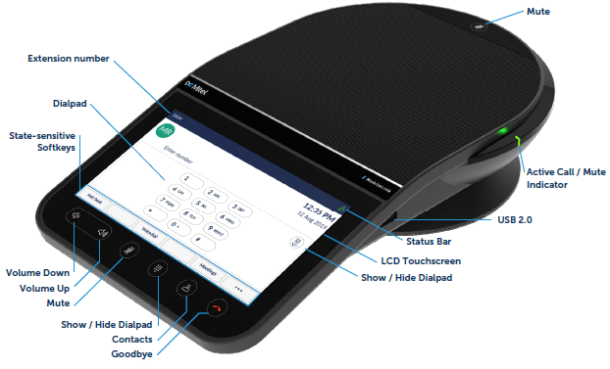

ADJUSTING THE SPEAKER VOLUME
During a call, press .

ADJUSTING THE RINGER VOLUME
When the phone is idle, press

TO ANSWER A CALL
- Press the Answer soft key

ENDING A CALL
- Press the Goodbye key or the END CALL soft key

EXTERNAL CALL
- Dial 9 +10-digit number for local calls, and 9 + 1 + 10 digits for long distance/toll free
- Press the SEND or DIAL soft key

INTERNAL CALL
- Dial the user’s extension (activates your speaker phone automatically).

CONFERENCE CALL
Connect up to four parties (including the originator) on one conference call.

To start a new Conference call
1. Begin with an active call or dial the number of the 1st party (9 plus the 10-digit external number)
2. Press the CONFRNC soft key, which places the first call on hold.
3. Next, dial the number of the 2nd party
4. Once the 2nd party answers, press the CONFRNC softkey again to join all the parties

TO ADD AN ENTRY IN THE CONTACT DIRECTORY
1. Press the MENU button, then select Features > Contact Directory
2. From the Directory screen, press the ADD soft key
3. Using the dial keypad, enter the contact information (example - to type the letter C, press the 2 button twice)

TO PLACE A CALL FROM THE CONTACT DIRECTORY
1. Press the Contacts button
2. Select the entry you wish to call.
3. Press the Dial or Call soft key

TO MUTE A CALL
1. During a call, press the MUTE Button 
Note: The console’s LEDs glow red to indicate that the phone is muted.
2. To Un-Mute, press the MUTE button again.

TO REDIAL A NUMBER
1. To redial the last number dialed, press the REDIAL soft key

TO PLACE A CALL ON HOLD
- Press the HOLD soft key to place the current call on hold.
Note: The console LEDs flash red to indicate that a call is on hold
- Press the RESUME soft key to retrieve the call.



